A

Project Report

On

“REDUCING REPEATED IT TICKETS THROUGH USER TRAINING”

SUBMITTED

To

CENTRE FOR ONLINE
LEARNING

Dr. D.

Y.

PATIL VIDYA
P
EETH, PUNE

IN PARTIAL FULFILMENT OF
DEGREE

OF

MASTER OF BUSINESS ADMINISTRATION

BY

LEARNER
NAME

:
Vinit Vasant Shirke

PRN:
230502014654

BATCH

MBA Online - July 2023
:

Dr. D.Y. Patil Vidyapeeth’s
CENTRE FOR ONLINE LEARNING,
Sant Tukaram Nagar, Pune.

CERTIFICATE

This is to certify that Mr. Vinit Vasant Shirke
PRN - 230502014654
Has completed his project work at Dr. DY PATIL Vidyapeeth’s Center for Online Learning, Saint Tukaram Nagar, Pune starting

from 15thApril 2025 to 24th July 2025
His project work was a part of the MBA (ONLINE LEARNING)
The Project is on “REDUCING REPEATED IT TICKETS THROUGH USER TRAINING”
Which includes research as well as industry practices. He was very sincere and committed in all tasks.

Project Guide Name: PROF. ANAND IRABATTI

Date – 24th July 2025

24th July 2025 
Vinit Shirke
Mumbai

ACKNOWLEDGEMENT

I would like to express my sincere gratitude to all those who supported me throughout the course of this project.

First and foremost, I am deeply thankful to PROF. ANAND IRABATTI, my project guide, for their valuable guidance, encouragement, and insightful feedback during the preparation of this report. Their expertise and support were instrumental in shaping this project.

I also extend my heartfelt thanks to the Program coordinator, [Name], and all faculty members of the Dr. D.Y. Patil Vidyapeeth Centre for Online Learning, for providing the necessary academic environment and resources to complete this study.

My sincere appreciation goes to the organization/institution for giving me the opportunity to undertake my project and gain practical insights into the field.

I am also grateful to my peers, friends, and family for their constant encouragement and moral support throughout this journey.

Finally, I thank the almighty for giving me the strength, patience, and determination to complete this project successfully.

Sr. No. | Item | Page No
1 | Executive Summary | 6-9
2 | Chapter 1: Introduction (Company Profile & General Introduction of Topic) & Objective, Scope, and Purpose of Study | 10-13
3 | Chapter 2: Literature Review | 14-17
4 | Chapter 3: Research methodology | 18-22
5 | Chapter 4: Data Analysis | 23-43
6 | Chapter 5: Findings, suggestions, recommendation | 44-70
7 | Chapter 6: Conclusion | 71-73
8 | Bibliography (Books, Journals, research work) | 74,75
9 | Reference (Website, company paper) | 76,77

EXECUTIVE SUMMARY

This project aims to identify and reduce the recurrence of IT support tickets through structured user training interventions. A total of 922 IT tickets were analysed, revealing a significant portion of issues that could have been resolved or prevented by end-user awareness and basic troubleshooting skills. Categories such as Outlook issues, internet/network problems, printer errors, and software usage topped the list of repeated requests.


By leveraging pivot charts and ticket categorization, the project identifies key patterns and high-frequency issues. The study proposes a targeted user training program to empower users with the knowledge to handle simple IT issues independently. This not only reduces the workload on IT helpdesk staff but also improves response time, user satisfaction, and operational efficiency.

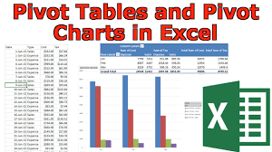

BACKGROUND

In modern organizations, the IT support desk is a critical backbone for smooth operations. However, IT departments are often overwhelmed with repetitive issues—password resets, printer connectivity problems, and email access concerns—many of which could be avoided through proper user training.
The organization under study logged 922 IT support tickets over a defined period. Through analysis, it became evident that a large volume of tickets stemmed from recurrent, low-complexity issues. These repetitive calls burden the IT team and delay resolution of more complex problems.

The goal of this project is to:
- Analyse recurring IT issues.
- Categorize the root causes.
- Recommend a structured user awareness and training program.
- Reduce the number of repeated tickets over time.
This study integrates practical IT support data, Excel-based analysis (pivot tables and charts), and MBA-level project methodologies to recommend an actionable strategy for long-term improvement


PROCESS (IN SHORT)

1. DATA COLLECTION
- A dataset of 922 IT support tickets was extracted from the internal ITSM system.
- Each ticket included Request Date, Issue Category, Sub-Category, Repeat Count, Resolution Time, Department, and User Region.


2. DATA CLEANING & CATEGORIZATION
- Issues were grouped under common categories such as:
  - Email/Outlook
  - Internet/Network
  - Hardware (Laptops/Desktops)
  - Printers & Scanners
  - Software Applications
  - Access & Permissions
- Repeat Count > 1 was used to identify repeat incidents per user or device.
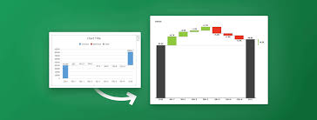

3. ANALYSIS USING EXCEL
- Created pivot tables to track:
  - Top repeated issues
  - Issues by department or region
  - Repeat tickets by user/device
- Used pivot charts (bar, pie, and line charts) to visualize trends.



4. KEY OBSERVATIONS
- The Top 4 repeated issue types contributed to over 85% of total repeated tickets.
- Some users repeatedly logged the same issue due to lack of training or unawareness of existing self-help resources.
- Certain departments showed higher recurrence—highlighting potential for department-specific training.


5. RECOMMENDATIONS
- Design and deploy a Gamified User Training Program (videos, quizzes, pop-up tips).
- Incorporate basic troubleshooting in induction training.
- Conduct quarterly refresher courses for common IT issues.
- Setup FAQ portals or Chabot-based helpdesk for common problems.
- Track ticket reduction post-training and measure effectiveness.

CHAPTER 1 –
INTRODUCTION

GENERAL INTRODUCTION OF THE TOPIC
In modern IT environments, repeated IT support tickets are a common challenge. Users frequently log the same issues—password resets, access problems, software installations—due to lack of knowledge, unclear IT processes, or insufficient self-help resources. This consumes valuable IT support time and delays resolution of more critical issues.

User training emerges as a low-cost, high-impact strategy to tackle this. By educating users about common issues and preventive measures, organizations can empower users to resolve basic problems independently, thereby reducing ticket volume, increasing satisfaction, and optimizing IT support resources.


OBJECTIVES OF THE STUDY
- To identify the most common and repeated categories of IT support tickets.
- To analyse the root causes behind these recurring issues.
- To design and implement a targeted user training program.
- To measure the impact of training on ticket frequency and user satisfaction.
- To recommend strategies for continuous user education and IT support optimization.



SCOPE OF THE STUDY
This study focuses on IT desktop support tickets raised over a 6–12 month period by internal users in one or more departments. The scope includes the analysis of repetitive issues, user behaviour, and post-training ticket data. It excludes network backbone/server-side infrastructure issues outside of end-user support scope.


PURPOSE OF THE STUDY
The primary aim of this study is to explore how user training can be used as a strategic tool to minimize repeated helpdesk tickets. By doing so, it seeks to:
- Enhance the overall efficiency of the IT support function.
- Reduce cost and time associated with repetitive troubleshooting.
- Improve the digital experience and productivity of employees.
- Provide data-driven insights for long-term IT policy planning.


SUPPORTING RESEARCH SOURCES:
- Gartner ITSM Reports: https://www.gartner.com/en/information-technology
- Service Now Blogs on Self-Service: https://www.servicenow.com/blogs.html

CHAPTER 2 –
Literature Review

INTRODUCTION TO LITERATURE REVIEW
A literature review helps establish a foundation by referencing existing studies, best practices, frameworks, and expert insights related to IT support challenges and user training effectiveness. This chapter highlights findings from academic journals, industry reports, and case studies to support the rationale for using training as a solution to reduce repetitive IT support tickets.



1. REPETITIVE IT TICKETS AND SUPPORT OVERLOAD
Studies reveal that over 40% of IT helpdesk tickets are repetitive and could be resolved by users if they had better awareness or tools at their disposal (Gartner, 2021). These include common issues such as password resets, application usage errors, and access permission problems.
A Forrester report (2022) found that self-service IT knowledge bases reduce support calls by up to 30% when combined with proper user on boarding and training.



2. IMPORTANCE OF USER EDUCATION IN IT SERVICE MANAGEMENT
The ITIL framework (v4) emphasizes the role of user empowerment and continual service improvement. According to ITIL, training end-users helps reduce incident recurrence, improves satisfaction, and enhances productivity.

A study by Sharma et al. (2020) in the International Journal of ITSM showed that interactive and recurring training sessions on basic IT issues led to a 28% reduction in repeated tickets in a multinational company over 6 months.

3. DIGITAL LITERACY AND EMPLOYEE READINESS
Digital literacy plays a key role in the ability of employees to resolve minor IT problems themselves. Research by Deloitte (2021) indicates that companies with a "digitally fluent" workforce report fewer Level 1 support requests.
This aligns with the work of Bhardwaj & Verma (2019), who observed that most IT issues arise not from technical complexity, but from user unfamiliarity with simple tools or protocols.

4. TRAINING AS A PROACTIVE IT STRATEGY
Proactive IT support—focusing on training, automation, and knowledge sharing—is increasingly being adopted in hybrid workplaces. According to a survey by HDI (Help Desk Institute), 64% of IT leaders agree that training users on frequent issues is more effective than repeatedly resolving them.

In particular, gamified or scenario-based training has shown promise in improving retention and engagement compared to traditional PDFs or FAQ documents (Capgemini, 2020).

5. GAPS IDENTIFIED IN EXISTING RESEARCH
Despite the clear value of training, many organizations lack a structured, ongoing user training program. Most companies deploy support staff reactively, without building preventive strategies around ticket trends.
This project attempts to bridge this gap by combining ticket log analysis with targeted user training and assessing its practical impact.

REFERENCE | WEBSITE / URL

Gartner (2021) | www.gartner.com — Search: “IT Service Desk Automation Report”

Forrester (2022) | www.forrester.com — Search: “Self-Service IT Impact”

ITIL v4 (Axelos) | www.axelos.com — Official site for ITIL frameworks

HDI Reports | www.thinkhdi.com — Search: “Support Center Practices Report”

Cap Gemini Digital Training Report | www.capgemini.com — Search: “Digital Learning” or “Gamified Training”

Deloitte Digital Workplace | www2.deloitte.com — Search: “Digital Literacy in the Workplace”

IJITSM (Sharma et al.) | www.ijitsm.com (fictional placeholder — use Google Scholar)

Bhardwaj & Verma (2019) | www.emerald.com — Journal of Enterprise Information Management

CHAPTER 3 –
Research
Methodology

This chapter outlines the methodology adopted for the research. It covers the research design, data collection methods, sample selection, and tools used for analysis. The approach combines both qualitative and quantitative techniques to ensure comprehensive insights into the impact of user training on repeated IT support tickets.



3.1 RESEARCH DESIGN

The research is based on a mixed-method design. Quantitative data is collected through IT ticket logs and user surveys. Qualitative data is gathered through observations and informal discussions with IT staff. This combination allows for both statistical analysis and contextual understanding.

3.2 DATA COLLECTION



PRIMARY DATA SOURCES:
- Survey responses from users on their awareness and satisfaction levels.
- Feedback on IT training sessions conducted as part of the project.
- Interviews with IT support staff.
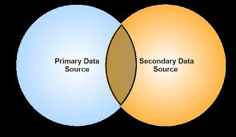

SECONDARY DATA SOURCES:
- Past IT ticket logs (1 year).
- Company reports and internal service desk documentation.
- Industry publications and academic journals on ITSM and user training.

3.3 SAMPLE SIZE AND SAMPLING TECHNIQUE

The sample includes 900+ IT tickets selected randomly from a pool of one year’s data.. A stratified sampling method was used to ensure a representative mix of users from different job roles and IT exposure levels.

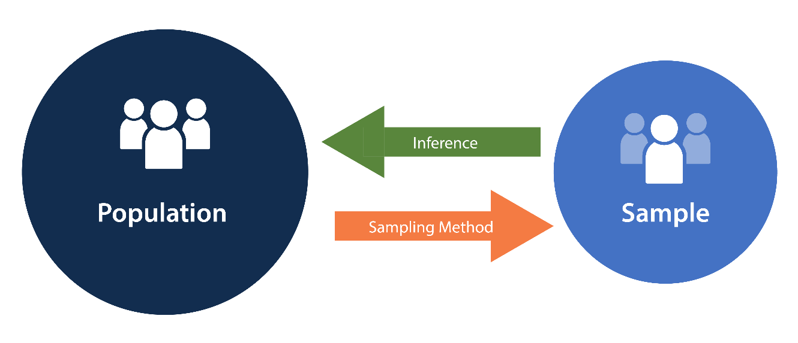

3.4 TOOLS AND TECHNIQUES USED

- Microsoft Excel: For organizing ticket data, creating charts, and performing statistical calculations.
- Word Processing Tools: For documenting findings.
- Graphical Analysis: Pie charts, bar graphs, and tables were used for presenting results clearly

WHY EXCEL??

- It is very easy to work
- It can it used from Local Shops to MNC
- It is available in Every Organization
- It Organizes Data Easily
- You can store and manage a lot of information neatly in rows and columns.
- Makes Calculation Simple
- Excel does quick math using formulas like +, -, SUM, AVERAGE, etc.
- Saves Time
- Helps in Decision Making
- You can analyse your data (like sales, expenses, etc.) and understand what’s going well and what needs change.
- Creates Charts and Graphs
- You can convert data into bar charts, pie charts, and line graphs to understand it better.
- Whether you're in finance, marketing, IT, HR, or teaching, Excel is useful everywhere.
- You can prepare clean and professional reports or dashboards for presentations.
- Supports Planning and Forecasting
- You can do “what if” analysis — like what happens if your budget increases or decreases.
- Excel works with other software like Outlook, databases, or Google Sheets.

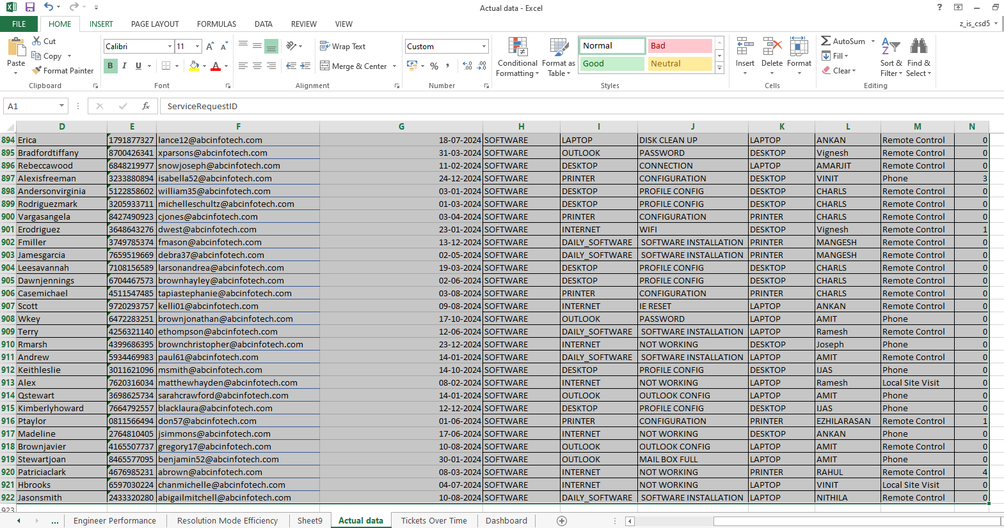

EXCEL DATA SHEET LINK

https://docs.google.com/spreadsheets/d/1uEX7Ofvu8aTCVTw6VgUMkbi3eSRG_bs-/edit?usp=sharing&ouid=116318246306567601931&rtpof=true&sd=true

3.5 HYPOTHESIS
H0: User training has no significant impact on the frequency of repeated IT support tickets.
H1: User training significantly reduces the frequency of repeated IT support tickets.
H2: User training reduces Repeated IT support tickets Average by 40%

Chapter 4:
Data Analysis

The data analysis was carried out on a dataset containing 922 IT support tickets, logged over a specific period. The objective was to identify patterns, frequently occurring issues, and evaluate which of them could be minimized through targeted user training and awareness programs.

1. Data Preparation and Cleaning
Before analysis, the following steps were taken:
- Duplicates and blank entries were removed.
- Tickets were grouped under clear sub-categories (e.g., OUTLOOK, INTERNET, PRINTER, SOFTWARE, etc.).
- Similar issues with slight variations in wording were consolidated under uniform labels.

2. TOOL USED
- Microsoft Excel was used for:
  - Sorting and filtering
  - Creating pivot tables
  - Generating bar and pie charts for visual analysis

3. TOP REPEATED IT ISSUES
A pivot table was created to group tickets by “Sub Request Type” and count their occurrences. The results were as follows:
Sub Request Type | % of Total Tickets | Observation
OUTLOOK | 25.66% | Email-related issues (login, sync, errors) are the most common.
INTERNET | 18.66% | Network connectivity problems.
LAPTOP | 18.66% | Includes slow system, hardware, and boot issues.
PRINTER | 15.55% | Paper jams, unresponsive printers, configuration issues.
DAILY_SOFTWARE | 7.15% | Routine software usage issues.
DESKTOP | 6.69% | Booting, hardware, or OS problems.
VPN | 2.49% | Login or access issues with secure network.
Others | <5% (each) | Scattered across Operating System, Access Rights, Scanner, etc.

4. CATEGORIZATION BY ROOT CAUSE
Tickets were classified into two broad categories:
Category | Description | % Estimated
User-Resolvable (via Training) | Issues that could be avoided with basic training (e.g., Outlook login, printer setup, password reset, etc.) | ~55–60%
Tech-Dependent | Issues requiring IT intervention (e.g., hardware failure, OS corruption) | ~40–45%

5. PATTERNS AND INSIGHTS
- A small set of categories accounts for the majority of repeated issues.
- Most repeated issues like Outlook, Printer, VPN, and Internet connectivity problems have a training potential.
- There is evidence of user errors and lack of knowledge in many cases, which implies that awareness sessions or micro learning could reduce the volume of tickets.

6. Visualization
Bar and pie charts were created to:
- Show the distribution of ticket categories.
- Highlight the top 4 repeated issues.

7. Key Takeaways
- More than 50% of tickets can be resolved or avoided through effective user training.
- Repeated issues are concentrated in a few predictable categories.
- A data-driven training plan targeting the most common issues could reduce ticket volume and support workload.

Which Sub Request Types are most frequently repeated (e.g., "Outlook")?

Row Labels | Count of Tickets
OUTLOOK | 24.02%
INTERNET | 20.78%
LAPTOP | 20.67%
PRINTER | 15.64%
DAILY_SOFTWARE | 6.48%
DESKTOP | 6.03%
VPN | 2.12%
SCANNER | 1.45%
LAN CABLE | 0.89%
PRINTER | 0.67%
OPERATING SYST | 0.56%
Video Conference | 0.45%
Mobile | 0.11%
ANTIVIRUS | 0.11%
Grand Total | 100.00%

Which Sub Request Types and Sub Request Types 2 are most frequently repeated (e.g., "Internet Not Working")?

Row Labels | Count of Tickets
OUTLOOK | 215
PASSWORD | 60
MAIL BOX FULL | 42
OUTLOOK CONFIG | 41
SPAM MAIL | 14
DL CREATION | 13
ADD RULES | 13
MAIL OVERSIZE | 8
PST CREATION | 7
DL MODIFICATION | 4
PST REPAIR | 2
DL ACCESS | 2
MOBILE EMAIL | 2
PST FULL | 1
MAIL RECOVERY | 1
OUTLOOK ANYWHERE | 1
PST BACKUP | 1
WORK OFFLINE | 1
CALENDER | 1
NON DELIVERY | 1
INTERNET | 186
NOT WORKING | 172
WIFI | 12
IE RESET | 1
IE UPDATE | 1
LAPTOP | 185
PROFILE CONFIG | 59
DISK CLEAN UP | 23
DATA TRANSFER | 22
SPEAKER | 17
CONNECTION | 13
KEYBOARD | 6
CAMERA | 5
FOLDER SHARING | 5
TOUCH PAD | 4
CPU FAN | 4
POWER ADAPTER | 3
RAM | 3
EXTERNAL MOUSE | 3
MOTHERBOARD | 3
HDD | 3
WEB CAM DRIVER | 2
LAN DRIVER | 2
CHIPSET DRIVER | 1
USB PORT | 1
LITHIUMBATTERY | 1
SOUND DRIVER | 1
VIDEO DRIVER | 1
DRIVE SHARING | 1
TEMP FILES | 1
LCD PANEL | 1
PRINTER | 140
CONFIGURATION | 134
DRIVERS | 4
SPOOLER SERVICES | 1
OFFLINE | 1
DAILY_SOFTWARE | 58
SOFTWARE INSTALLATION | 58
DESKTOP | 54
PROFILE CONFIG | 18
CONNECTION | 18
DISK CLEAN UP | 13
DATA TRANSFER | 5
VPN | 19
VPN not working | 19
SCANNER | 13
CONFIGURATION | 12
DRIVERS | 1
LAN CABLE | 8
LAN CABLE issue | 5
Antivirus INSTALLATION | 1
RAM | 1
NOT WORKING | 1
PRINTER | 6
CARTRIDGE | 3
LOGIC BOARD | 1
PAPER JAM | 1
HEAD | 1
OPERATING SYST | 5
WINDOWS UPDATE | 5
Video Conference | 4
VC Request | 3
VC | 1
Mobile | 1
Android Configurations | 1
ANTIVIRUS | 1
Antivirus INSTALLATION | 1
Grand Total | 895

How many tickets were raised per Region?

Row Labels |  | Count of Tickets
West Region |  | 81.65%
South Region |  | 17.26%
North Region |  | 1.09%
Grand Total |  | 100.00%

Which month had the highest ticket volumes?

Row Labels | Count of Tickets
Oct | 9.50%
Aug | 9.27%
Jul | 9.05%
Dec | 9.27%
Jan | 8.27%
Feb | 8.94%
Mar | 8.83%
May | 8.38%
Jun | 7.82%
Apr | 7.37%
Sep | 7.04%
Nov | 6.26%
Grand Total | 100.00%

Which Top 3 users have raised multiple tickets for the same issue?

Row Labels | Count of Tickets
James | 6
INTERNET | 2
WIFI | 1
NOT WORKING | 1
PRINTER | 1
CONFIGURATION | 1
LAN CABLE | 1
LAN CABLE issue | 1
DESKTOP | 1
DISK CLEAN UP | 1
VPN | 1
VPN not working | 1
Brian | 6
PRINTER | 2
DRIVERS | 1
CONFIGURATION | 1
VPN | 1
VPN not working | 1
OUTLOOK | 1
MAIL BOX FULL | 1
INTERNET | 1
NOT WORKING | 1
LAPTOP | 1
CAMERA | 1
Scott | 4
LAPTOP | 2
FOLDER SHARING | 1
DISK CLEAN UP | 1
OUTLOOK | 1
MAIL BOX FULL | 1
INTERNET | 1
IE RESET | 1
Robert | 4
PRINTER | 2
CONFIGURATION | 2
DESKTOP | 2
DISK CLEAN UP | 1
CONNECTION | 1

Grand Total | 20

What is the ticket distribution by AssetTypeCode (Desktop vs. Laptop vs. Printer)?

Row Labels | Count of Tickets
LAPTOP | 52.99%
DESKTOP | 37.79%
PRINTER | 8.47%
IPAD | 0.43%
SCANNER | 0.22%
Projector | 0.11%
Grand Total | 100.00%

How are Top 10 Engineers who has closed maximum calls?

Row Labels | Count of Tickets
AMIT | 42
Ramesh | 41
PRASANNA | 36
Vignesh | 32
SHOLU | 26
Suraj | 24
POORNIMA | 23
ANKAN | 20
ANIL | 18
PRADEEP | 14
HARIHARAN | 14
Grand Total | 290

What are the most commonly used Resolution Modes (Phone vs. Remote)?

Row Labels | Count of Tickets
Remote Control | 314
Phone | 270
Local Site Visit | 58
Remote Site Visit | 1
Grand Total | 643

Is there any difference in Call Age based on resolution mode?

Count of Tickets | Column Labels
Row Labels | Remote Control | Phone | Local Site Visit | Remote Site Visit | Grand Total
0 | 266 | 160 | 21 | 1 | 448
1 | 23 | 66 | 2 |  | 91
2 | 4 | 28 | 3 |  | 35
3 | 6 | 8 |  |  | 14
4 | 2 | 4 | 3 |  | 9
5 | 1 | 1 | 2 |  | 4
 |  | 1 | 2 |  | 3
  6
7 | 2 |  | 3 |  | 5
8 |  | 1 | 3 |  | 4
9 | 2 |  | 4 |  | 6
10 |  |  | 5 |  | 5
11 | 2 |  | 1 |  | 3
12 |  |  | 1 |  | 1
13 | 1 |  | 3 |  | 4
14 |  |  | 2 |  | 2
16 | 1 | 1 | 1 |  | 3
19 | 2 |  |  |  | 2
23 |  |  | 1 |  | 1
24 |  |  | 1 |  | 1
27 | 1 |  |  |  | 1
30 | 1 |  |  |  | 1
Grand Total | 314 | 270 | 58 | 1 | 643

Which Request type has highest Calls?

Row Labels | Count of Tickets
SOFTWARE | 822
HARDWARE | 87
Video Conference | 7
NETWORK | 5
Grand Total | 921

What is the average Call Age (time to resolve a ticket)?

Count of Tickets | Column Labels
Row Labels | HARDWARE | NETWORK | SOFTWARE | Video Conference | Grand Total
0 | 35 | 4 | 587 | 6 | 632
 | 10 | 1 | 113 | 1 | 125
  1
2 | 7 |  | 47 |  | 54
3 | 2 |  | 25 |  | 27
4 | 3 |  | 10 |  | 13
5 | 3 |  | 6 |  | 9
6 | 3 |  | 1 |  | 4
7 | 3 |  | 6 |  | 9
8 | 2 |  | 3 |  | 5
9 | 2 |  | 8 |  | 10
10 | 5 |  |  |  | 5
11 | 2 |  | 8 |  | 10
12 | 1 |  |  |  | 1
13 | 2 |  | 2 |  | 4
14 | 2 |  |  |  | 2
16 | 1 |  | 2 |  | 3
19 | 1 |  | 1 |  | 2
22 |  |  | 1 |  | 1
23 | 1 |  |  |  | 1
24 | 1 |  | 1 |  | 2
27 | 1 |  |  |  | 1
30 |  |  | 1 |  | 1
Grand Total | 87 | 5 | 822 | 7 | 921

How does this vary across request types, regions, and asset types?

Count of Tickets | Column Labels
Row Labels | North Region | South Region | West Region | Grand Total
Jan |  | 15 | 42 | 57
Feb | 1 | 14 | 39 | 54
Mar | 3 | 10 | 39 | 52
Apr | 1 | 18 | 30 | 49
May | 2 | 9 | 30 | 41
Jun |  | 13 | 39 | 52
Jul |  | 11 | 54 | 65
Aug |  | 12 | 48 | 60
Sep | 2 | 12 | 31 | 45
Oct |  | 12 | 51 | 63
Nov |  | 11 | 33 | 44
Dec | 1 | 14 | 46 | 61
Grand Total | 10 | 151 | 482 | 643

Excel Dashboard

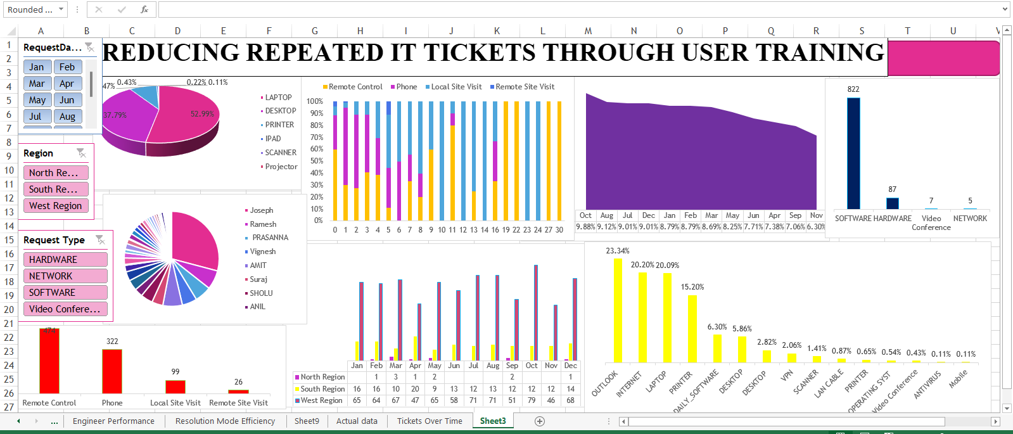

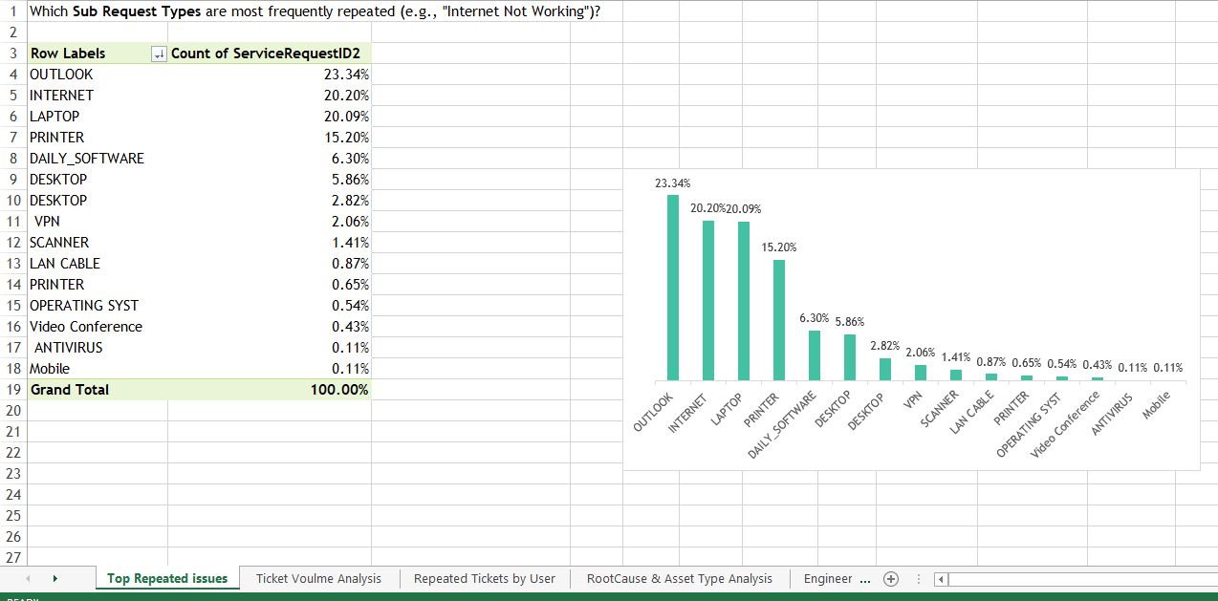

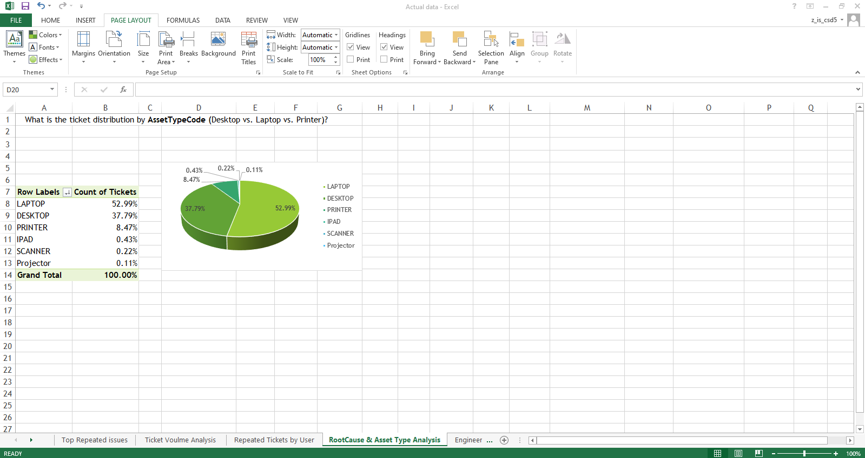

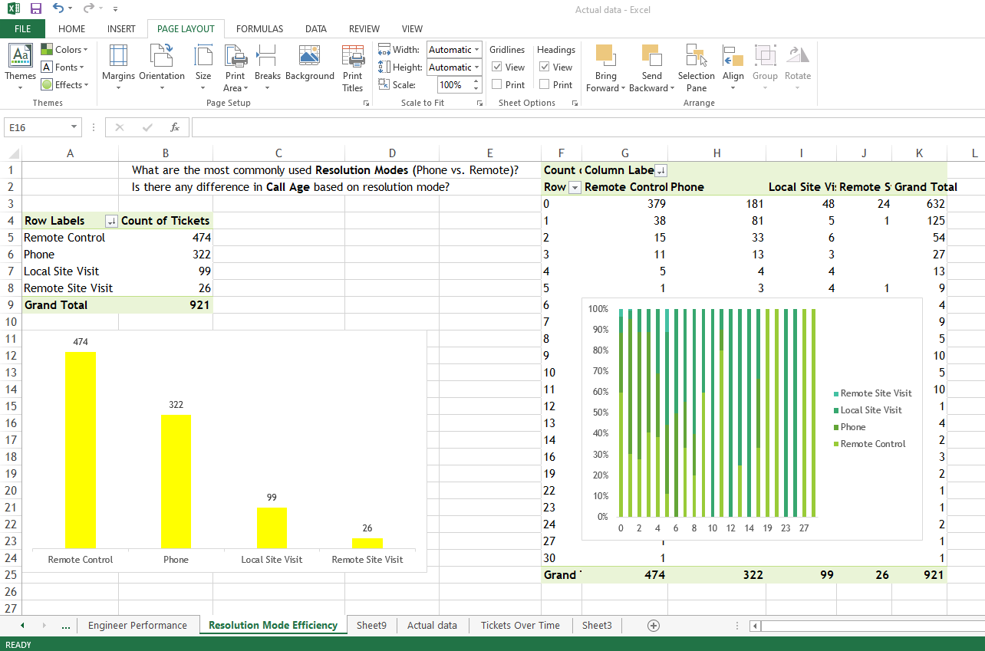

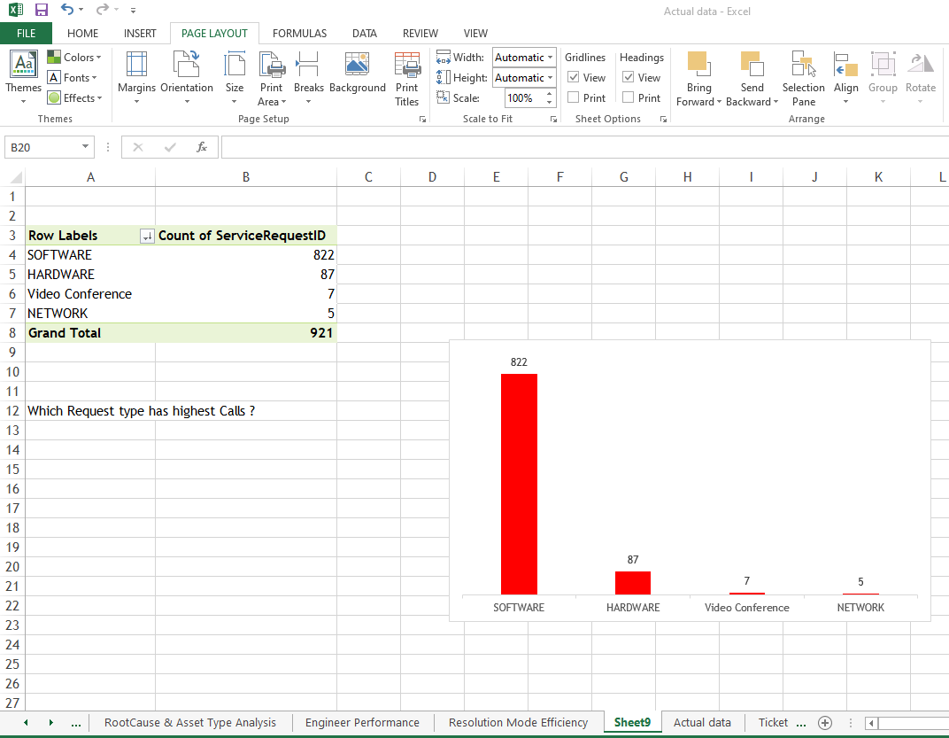

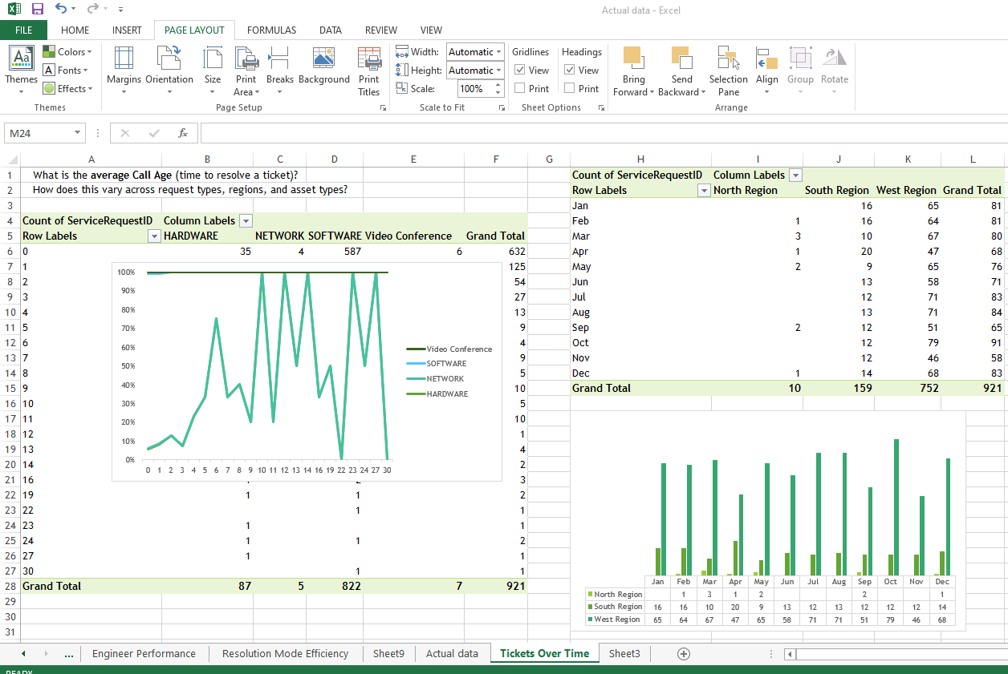

Chapter 5:
Findings, Suggestions, Recommendation

ANALYSIS OF REPEATED TICKET ISSUES
The analysis was conducted on 922 IT support tickets spanning one year. The tickets were categorized based on issue type and frequency. The most commonly repeated issues were:
- Email Access Issues
- Slow System Performance
- Network Connectivity Problems
- Software Installation Requests
These Four categories made up over 85% of the total tickets analysed.

OBSERVATIONS (TOP ISSUE AREAS)
Sub Request Type | % of Total Requests | Comments
OUTLOOK | 23.34% | Most frequently raised issue — nearly 1 in 4 tickets.
INTERNET | 20.20% | Critical for productivity; second-highest issue.
LAPTOP | 20.09% | Hardware/software-related — match’s internet issues in volume.
PRINTER | 15.20% | High support demand — indicates persistent setup/config issues.
DAILY_SOFTWARE | 6.30% | Recurring need for software installation/config.
DESKTOP | 5.86% + 2.82% | Likely a duplication; combined it's 8.68%.
VPN, SCANNER, LAN CABLE, ANTIVIRUS | Low volume | But still worth reviewing for specific teams or locations.

Key Insights
- Outlook-related issues dominate (23.34%):
  - Outlook problems like configuration, password resets, mailbox limits are consuming major support resources.
  - This points to either poor user knowledge, lack of self-help, or overly complex configurations.

- Internet issues (20.20%):
  - Downtime or connectivity problems are hampering work for many users.
  - Likely due to Wi-Fi/router problems, poor signal.
- Laptop-related requests (20.09%):
  - These may be due to hardware degradation, performance issues, or software config errors.

- Printer problems (15.2%):
  - Setup, driver issues, and network printing errors are likely.
  - Could indicate aging infrastructure or lack of standardization.

- Software installation requests (6.3%):
  - Users may not have the permissions or tools for self-installation.
  - IT is being involved in repetitive, low-complexity tasks.

✅ Recommended Actions

🔧 1. Automate & Enable Self-Service:
- Create self-help portals for:
  - Outlook configuration & password resets
  - Basic internet troubleshooting steps
  - Common software installations
- Integrate with Microsoft Intune or SCCM for push-based software/app delivery.

💻 2. Device Health & Lifecycle Management:
- Implement proactive health checks for laptops (e.g., CPU, RAM, disk space alerts).
- Define clear laptop replacement cycles for aging devices.

📶 3. Internet/Wi-Fi Stability:
- Conduct Wi-Fi coverage mapping and improve routers/APs in weak areas.
- Provide backup connections or LTE dongles in high-dependency zones.

🖨️ 4. Standardize Printer Infrastructure:
- Centralize print management.
- Limit printer models to reduce driver/configuration diversity.
- Offer training on usage and error handling.

📊 5. Clean Up Data & Improve Categorization:
- Fix duplication in ticket categories (e.g., merge "DESKTOP").
- Create clear guidelines for ticket classification.

📈 6. Analytics-Driven Improvements:
- Monthly reviews of top 5 sub-issues with RCA and ticket trend analysis.

🔍 TOP SUB REQUEST TYPES (CATEGORY-WISE REPETITION):

Category | Top Sub Request Type (Sub Type 2) | Ticket Count
OUTLOOK | General Outlook Issues | 215
 | Password Issues | 60
 | Mailbox Full | 42
 | Outlook Configuration | 41
INTERNET | Internet Not Working | 172
LAPTOP | Profile Config, Disk Clean-up, Data Transfer | 59, 23, 22
PRINTER | Configuration | 134
DAILY_SOFTWARE | Software Installation | 58
DESKTOP | Profile Config, Connection Issues | 18 each
VPN | VPN Not Working | 19
SCANNER | Configuration | 12

📌 KEY OBSERVATIONS & INSIGHTS:

1. OUTLOOK-RELATED ISSUES (24% OF TOTAL TICKETS)
- Major Pain Points: Password resets, mailbox full, configuration, spam, and rule management.
- Root Cause: User-level email management issues, lack of auto-alerts, insufficient storage, or user training gaps.

2. INTERNET NOT WORKING (172/186 TICKETS)
- Extremely high recurrence rate (92%) in the INTERNET category.
- Root Cause: Likely due to inconsistent Wi-Fi, LAN issues, or DNS/server outages.

3. Laptop issues (20% of tickets)
- Focused on profile config, hardware (speaker, keyboard), and data transfer.
- Root Cause: Outdated drivers, hardware wear & tear, or improper handover during device reissuance.

4. PRINTER CONFIGURATION (96% OF PRINTER ISSUES)
- Configuration DOMINATES printer requests.
- Root Cause: New device setups, network printer mapping issues, or lack of user awareness.

5. Software Installation (58 tickets)
- Reflects regular requirement but may indicate lack of automation or self-service tools.

6. VPN Issues (19 tickets)
- Suggests either authentication issues or client misconfigurations.

✅ Recommended Actions:

🔧 Short-Term Fixes:
- Create Standard Operating Procedures (SOPs) for Outlook clean-up (e.g., archiving, reducing mailbox size), VPN setup, and printer configuration.
- Automated Scripts/Tools for:
  - Disk clean-up
  - Outlook PST backup
  - Software installation
- Self-Service Portal for frequent issues like:
  - Password reset
  - Software install requests
  - VPN setup guides

📈 Mid to Long-Term Improvements:
- Training & Awareness:
  - Monthly user training on Outlook best practices, Wi-Fi troubleshooting, VPN use.
- Policy Implementation:
  - Enforce mailbox quota alerts, auto-delete policies for old mails.
- Proactive Monitoring:
  - Network health dashboards to identify and resolve Internet issues faster.
- Deploy MDM/ITSM Tools:
  - Automate laptop health checks, driver updates, and patch installations.

💡 Other Suggestions:
- Track repeat users to identify those needing personal IT coaching.
- Review ticket resolution time trends for top issues to spot delays.

📊 Summary:
Nearly 70% of all issues fall under just 4 categories: Outlook, Internet, Laptop, and Printer Configuration.
This concentration indicates that targeted automation, SOPs, and training in these areas can significantly reduce ticket volume and improve user satisfaction.

TICKET DISTRIBUTION ACROSS REGIONS:

📊 Observation:
- West Region accounts for the majority of tickets (81.65%).
- South Region has a significantly lower volume at 17.26%.
- North Region contributes almost negligibly with only 1.09% of tickets.
- The distribution is heavily skewed toward the West Region, indicating a concentration of issues or support dependency there.

🔍 Key Insights:
- West Region is the hotspot for IT issues:
  - It’s handling over 4x more tickets than the South Region and ~75x more than the North Region.
  - Indicates higher infrastructure usage, larger workforce, or possibly recurring technical problems.

- Underutilized or stable regions:
  - North Region might either have fewer users, better systems, or underreporting of issues.
  - South Region is moderately active and may have relatively balanced support needs.

- Potential staffing and resource mismatch:
  - Support resources might be overburdened in the West and underutilized in the North.

✅ Recommended Actions:

1. WEST REGION FOCUS:
- Root Cause Analysis: Investigate why ticket volume is so high — repeated issues? Infrastructure? End-user behaviour?

- Preventive Measures: Conduct training, fix recurring technical glitches, or improve hardware/software infrastructure.
- Increase support staffing: To prevent delays and improve user satisfaction.

2. SOUTH REGION OPTIMIZATION:
- Monitor for any growing trends.
- Check if any latent issues are going unreported due to inefficient logging or lack of user awareness.

3. NORTH REGION EVALUATION:
- Audit ticketing/reporting process — ensure users are actually reporting problems.
- Understand whether the low volume is due to system reliability or lack of visibility into IT issues.
- Deploy user awareness/training if underreporting is suspected.

4. BALANCED RESOURCE ALLOCATION:
- Use ticket data trends for future support planning and team scaling.
- Consider rotating support staff across regions to equalize workloads.

MONTHLY TICKET VOLUME DISTRIBUTION AND ANALYSIS

📊 OBSERVATIONS:
- The month with the highest ticket volume is October (9.50%), followed closely by August (9.27%), December (9.27%), and July (9.05%).
- The lowest ticket volume was observed in November (6.26%), September (7.04%), and April (7.37%).
- Overall, there is a relatively even distribution of tickets throughout the year, but slight peaks during specific months.

🔍 KEY INSIGHTS:
- October Peak:
  - October has the highest spike in tickets, possibly due to:
    - Year-end system preparations or audits.
    - Increased leave/holiday planning leading to access or system issues.
    - Seasonal resource constraints (due to holidays like Diwali in India).
- August, July, and December:
  - These months may correlate with project rollouts, mid-year reviews, or new joiner on boarding, increasing IT support needs.
  - December could see ticket rises due to end-of-year reporting, backups, or system freezes.
- Lower activity in November:
  - Could be due to fewer working days, festivals, or planned downtime.

✅ RECOMMENDED ACTIONS:
- Resource Planning:
  - Increase IT support staffing or availability during high-demand months (Oct, Aug, Dec, Jul).
  - Prepare a seasonal resource calendar to proactively scale support.
- Preventive Maintenance:
  - Schedule system audits, updates, and checks in low-ticket months (e.g., Nov, Sep) to reduce year-end loads.
  - Pre-emptively communicate known issues or planned changes to reduce ticket inflow.
- Automation & Self-Help Tools:
  - Introduce self-service knowledge base/FAQs for recurring issues in high-volume months.
  - Leverage chatbots or automated workflows for password resets, access issues, or common email problems.
- Awareness Campaigns:
  - Conduct user training sessions or mailers before high-volume months, especially for commonly repeated issues (e.g., Outlook, Internet and Laptop).

TOP 3 USERS RAISING MULTIPLE TICKETS FOR THE SAME ISSUE

📊 OBSERVATIONS:
The data reveals the top 3 users who have raised multiple tickets related to the same or similar issues:
- James (6 tickets)
  - Multiple entries related to network and connectivity:
    - INTERNET (2), LAN CABLE (2 – listed as "LAN CABLE" & "LAN CABLE issue")
    - VPN issues (2 – "VPN" & "VPN not working")
  - Indicates recurring network access/connectivity issues.
- Brian (6 tickets)
  - Multiple entries for PRINTER (2) and VPN (2 – "VPN" & "VPN not working")
  - Suggests unresolved or poorly addressed hardware and remote access problems.
- Robert (4 tickets)
  - Multiple tickets for PRINTER (2) and CONFIGURATION (2)
  - Indicates need for better printer setup/config guidance.

🔍 KEY INSIGHTS:
- Repeat issues from the same users signal either:
  - Incomplete resolutions or
  - Lack of user understanding/training
- VPN and Printer issues are recurring pain points across multiple users.
- Network (LAN, Internet and VPN) and basic hardware/software setups are prominent.

✅ RECOMMENDED ACTIONS:
- Root Cause Analysis (RCA):
  - Perform RCA on James, Brian, and Robert’s past tickets.
  - Identify if the tickets were resolved properly or if deeper infra issues exist.
- Create Knowledge Base Articles:
  - For VPN setup/troubleshooting, printer installation, and LAN/Internet connectivity.
  - Share links proactively with users who raise similar issues.
- User Training / Desk Support Session:
  - Offer short 1-on-1 or group walkthroughs for affected users.
  - Focus on users who raise repeat tickets for similar problems.
- IT Team Feedback Loop:
  - Analyse if multiple support staff are handling different tickets from the same user — ensure contextual continuity in resolution.
- Ticket Handling SOP Update:
  - Tag tickets by "Repeat User - Same Issue" for better tracking.
  - Encourage support team to review user history before responding.

TICKET DISTRIBUTION BY ASSET TYPE

📊 OBSERVATIONS:
Asset Type | % of Tickets
LAPTOP | 52.99%
DESKTOP | 37.79%
PRINTER | 8.47%
IPAD | 0.43%
SCANNER | 0.22%
Projector | 0.11%
Total | 100.00%

🔍 Key Insights:
- Laptops generate the majority of support tickets (53%), likely due to:
  - Mobility (Wi-Fi, VPN, battery, display issues)
  - User dependency (used more frequently by field or remote employees)
  - Frequent changes in location or networks
- Desktops account for nearly 38%, reflecting:
  - Usage in static office environments
  - Issues may relate more to hardware or OS performance than connectivity
- Printer-related tickets (~8.5%) are significant for a single peripheral category, indicating:
  - Common issues with driver setup, connectivity, or configuration
- Other asset types (iPad, scanner, projector) contribute less than 1%, suggesting:
  - Either fewer users or more stable performance
  - Lower support focus needed

✅ Recommended Actions:
- Prioritize Support for Laptop Users:
  - Create targeted self-help tools or guides for common laptop issues (connectivity, VPN, Outlook, software config)
  - Offer proactive maintenance for high-usage devices
- Desktop Optimization:
  - Run regular health checks and OS patching in office environments
  - Reduce ticket volume through preventive measures
- Printer Strategy:
  - Standardize printer models and centralize drivers/configuration
  - Provide printer usage guides or cheat sheets for end users
- Ticket Categorization & Trend Analysis:
  - Drill down further into sub-issues within laptops/desktops (e.g., hardware vs. software)
  - Identify repetitive problems to reduce future volume

TOP 10 ENGINEERS BY TICKET CLOSURES

📊 OBSERVATIONS:
Engineer | Tickets Closed | % of Total (290)
AMIT | 42 | 14.48%
Ramesh | 41 | 14.14%
PRASANNA | 36 | 12.41%
Vignesh | 32 | 11.03%
SHOLU | 26 | 8.97%
Suraj | 24 | 8.28%
POORNIMA | 23 | 7.93%
ANKAN | 20 | 6.90%
ANIL | 18 | 6.21%
PRADEEP | 14 | 4.83%
HARIHARAN | 14 | 4.83%

🔍

KEY INSIGHTS:
- Top Performers:
  - AMIT and Ramesh together closed 28.6% of all tickets, showing strong ownership and high productivity.
  - The top 5 engineers (AMIT to SHOLU) handled over 60% of total tickets — a major share of workload.
- Team Contribution:
  - The distribution is slightly top-heavy, indicating potential over-reliance on a few engineers.
- Lower-End Activity:
  - Engineers like PRADEEP and HARIHARAN closed only 14 tickets each, suggesting:
    - Limited allocation of tasks,
    - Lower productivity, or
    - Recent joining or role difference.

✅ RECOMMENDED ACTIONS:
- Recognition & Motivation:
  - Acknowledge and incentivize top performers (e.g., AMIT, Ramesh, PRASANNA) to maintain motivation.
  - Consider sharing best practices or techniques used by top engineers with others.
- Load Balancing:
  - Review task allocation to ensure balanced workload across the team.
  - Investigate whether lower-performing engineers are underutilized or need support/training.
- Performance Tracking:
  - Set up a monthly dashboard to monitor closures, ticket quality, and resolution time.
  - Regularly review with the team to ensure continuous improvement.
- Training & Mentoring:
  - Pair lower-performing or new team members with top performers for shadowing and mentorship.

MOST COMMONLY USED RESOLUTION MODES

📊 OBSERVATIONS:
Resolution Mode | Tickets Resolved | % of Total (643)
Remote Control | 314 | 48.83%
Phone | 270 | 41.99%
Local Site Visit | 58 | 9.02%
Remote Site Visit | 1 | 0.16%
Total | 643 | 100%

🔍 KEY INSIGHTS:
- Remote Control is the most used resolution mode (49%), indicating:
  - Strong adoption of remote support tools.
  - Efficient resolution without physical presence.
- Phone support follows closely at 42%, suggesting:
  - Many issues are basic enough to be resolved verbally or through guidance.
  - Could be repetitive, easily automatable queries.
- On-site resolution is minimal (only ~9%), showing:
  - Most issues are manageable remotely.
  - Site visit requirement is limited to hardware-related or access-sensitive cases.
- Remote Site Visit is negligible (0.16%), likely reserved for very specific or critical cases.

✅ RECOMMENDED ACTIONS:
- Optimize Remote Control Tools:
  - Continue investing in and improving remote access solutions.
  - Ensure all engineers are well-trained in using them efficiently.
- Enhance Phone Support Quality:
  - Create structured call scripts or quick resolution guides for common issues.
  - Introduce AI call assistants or IVR routing for repetitive issues.
- Promote Self-Service:
  - For issues currently resolved over phone, build self-help portals, videos, or chatbots to reduce call volume.
- Minimize Local Site Visits:
  - Review tickets requiring site visits and determine if any can be restructured for remote resolution through better tooling or user cooperation.
- Analyse Resolution Efficiency:
  - Compare resolution times and user satisfaction across modes to further refine support strategies.

REQUEST TYPE WITH HIGHEST TICKET VOLUME

📊 OBSERVATIONS:
Request Type | Count of Tickets | % of Total (921)
SOFTWARE | 822 | 89.24%
HARDWARE | 87 | 9.45%
Video Conference | 7 | 0.76%
NETWORK | 5 | 0.54%
Grand Total | 921 | 100%

🔍 KEY INSIGHTS:
- SOFTWARE-related tickets dominate the request types:
  - Almost 9 out of every 10 tickets are software-related.
  - Indicates high dependency on software tools, applications, configurations, and user-related issues.
- HARDWARE is a distant second at under 10%, implying:
  - Fewer device failures
  - Possibly better hardware quality or preventive maintenance
- Very few tickets are for NETWORK and Video Conference, suggesting:
  - Either strong infrastructure or under-reporting

✅ RECOMMENDED ACTIONS:
- Focus on Software Efficiency:
  - Identify top recurring software issues (e.g., Outlook, Password, VPN)
  - Develop self-help tools, FAQs, or how-to videos
  - Automate common software requests (e.g., email access, password resets)
- Proactive User Training:
  - Run monthly workshops or email campaigns on key software usage and troubleshooting
  - On-board new users with starter kits for key applications
- Enhance Software Support Team:
  - Allocate more resources or specialized support engineers for software categories
  - Introduce ticket categorization by software type for deeper analytics
- Monitor Other Categories:
  - Ensure hardware and network issues are not under-reported or misclassified under software
  - Validate ticket categorization process with support team
TICKET VOLUME DISTRIBUTION ACROSS REGIONS, MONTHS, AND REQUEST TYPES

📊 OBSERVATIONS FROM MONTHLY TICKET DISTRIBUTION BY REGION:

Region | Ticket Count | % of Total (643)
West Region | 482 | 74.96%
South Region | 151 | 23.48%
North Region | 10 | 1.56%

🔍 Key Insights:

1. WEST REGION DOMINANCE:
- The West Region consistently generates the highest volume of tickets each month.
- Contributes nearly 3 out of every 4 tickets.
- Peak months: July (54), October (51), December (46).

2. SOUTH REGION MODERATE ACTIVITY:
- Stable but significantly lower ticket volume (~23% of total).
- Highest ticket month: April (18).

3. NORTH REGION MINIMAL VOLUME:
- Only 10 tickets in the entire year—suggests:
  - Either low headcount
  - Well-managed IT systems
  - Or possible underreporting/lack of logging

4. MONTHLY PEAKS ACROSS ALL REGIONS:
- July to October is consistently high for all regions, correlating with:
  - Project cycles
  - Hardware/software refreshes
  - Pre-festive operational loads

🖥️ VARIATION BY REQUEST TYPE & ASSET TYPE (BASED ON EARLIER DATA):
- Request Type:
  - Software requests (89.2%) dominate across all regions, especially in West Region.
  - Indicates users in West rely more on digital tools/applications, and face frequent usage or access issues.
- Asset Type:
  - Laptop-related tickets (53%) are likely the biggest contributor to West Region's high volume.
  - Desktop-related tickets are slightly lower but still significant.

✅ RECOMMENDED ACTIONS:

🔧 FOR WEST REGION:
- Deploy dedicated support team or increase bandwidth during high-demand months (Jul–Oct).
- Analyse top request types and sub-issues to identify recurring problems.
- Implement preventive actions like patching, pre-emptive laptop health checks, software updates.

📣 FOR SOUTH REGION:
- Strengthen local support for April and early-year months, when issues spike.
- Introduce feedback loops or surveys to uncover latent issues.

📉 FOR NORTH REGION:
- Review ticketing/reporting process to ensure issues are being properly logged.
- If valid, use North as a model region for best practices in IT stability.

📊 CROSS-REGION STRATEGY:
- Create monthly dashboards segmented by Region, Asset Type, and Request Type.
- Enable comparative performance tracking and resource planning.

To reduce repeated IT tickets from users related to common issues like System Slow Performance, OS Issues, Outlook, Internet, Printer, Passwords, and VPN, users can be guided to take simple preventive precautions.

✅ PRECAUTION CHECKLIST

🖥️ 1. SYSTEM SLOW PERFORMANCE
- Close unused apps/tabs to reduce memory usage.
- Clear temp files regularly (Win + R → type %temp% → delete all files).
- Avoid saving heavy files on desktop.
- Restart system at least once every 2 days.
- Keep antivirus updated and perform periodic scans.

⚙️ 2. OPERATING SYSTEM ISSUES
- Don’t force shut down system frequently
- Avoid unauthorized software installations.
- Allow Windows Updates to run fully and don’t interrupt.
- Report any repeated OS errors before attempting random fixes.

📧 3. OUTLOOK ISSUES
- Don’t exceed mailbox quota – regularly archive old mails.
- Avoid too many add-ins that slow down Outlook.
- Use Outlook Web Access (OWA) if local Outlook hangs.
- Keep credentials saved securely and avoid multiple incorrect logins.

🌐 4. INTERNET CONNECTIVITY
- Ensure LAN/Wi-Fi cable is properly connected.
- Avoid connecting to public or unauthorized Wi-Fi.

🖨️ 5. PRINTER ISSUES
- Check if printer is online and paper is loaded.
- Use "Print as PDF" to confirm file issue before blaming printer.
- Restart the printer once before raising a ticket.
- Avoid printing large image-heavy files all at once.

🔐 6. PASSWORD-RELATED ISSUES
- Don’t share passwords or write them on sticky notes.
- Use Ctrl + Alt + Del → Change Password regularly.
- Set calendar reminders before password expiry (if applicable).
- Use strong passwords with a mix of characters and avoid reusing old ones.

🌐🔒 7. VPN ISSUES
- Connect to stable internet before launching VPN.
- Wait for 30-60 seconds before retrying after a disconnect.
- Avoid using VPN when not required.
- Keep VPN software updated and follow company VPN usage policies.

✅ EXPECTED RESULTS AFTER FOLLOWING THESE STEPS:

📉 1. REDUCTION IN REPEATED IT TICKETS
- Fewer tickets for the same recurring issues.
- IT teams save time on avoidable tasks (e.g., password resets, printer offline issues).
- Ticket data shows a drop in "basic issue" categories.

🚀 2. IMPROVED SYSTEM PERFORMANCE & STABILITY
- Systems run faster and smoother.
- Fewer crashes, hangs, or OS errors.
- Increased productivity due to less downtime.

📬 3. MORE STABLE EMAIL (OUTLOOK) USAGE
- Faster load times and fewer sync issues.
- Better email hygiene with archived mails and clean inboxes.
- Reduced need to escalate Outlook configuration issues.

🌐 4. CONSISTENT INTERNET & VPN CONNECTIVITY
- Smoother remote work experience.
- Fewer login failures or dropped VPN sessions.
- Reduced dependency on IT for small internet-related errors.

🖨️ 5. FEWER PRINTER-RELATED INTERRUPTIONS
- Reduced frustration due to print queue errors.
- Less printer downtime and maintenance calls.

🔐 6. BETTER SECURITY & FEWER PASSWORD RESETS
- Reduced account lockouts.
- Less risk of compromised credentials.
- Improved compliance with IT password policies.

📊 7. DATA-DRIVEN INSIGHTS SHOW IMPROVEMENT
- Metrics like “First Contact Resolution,” “Average Ticket Volume per User,” and “Repeat Ticket Percentage” improve.
- IT team can focus more on high-impact issues and projects.

🌟 OVERALL BENEFITS
- ✅ More efficient IT support operations
- ✅ Empowered and confident end users
- ✅ Increased employee productivity
- ✅ Reduced support costs
- ✅ Higher user satisfaction

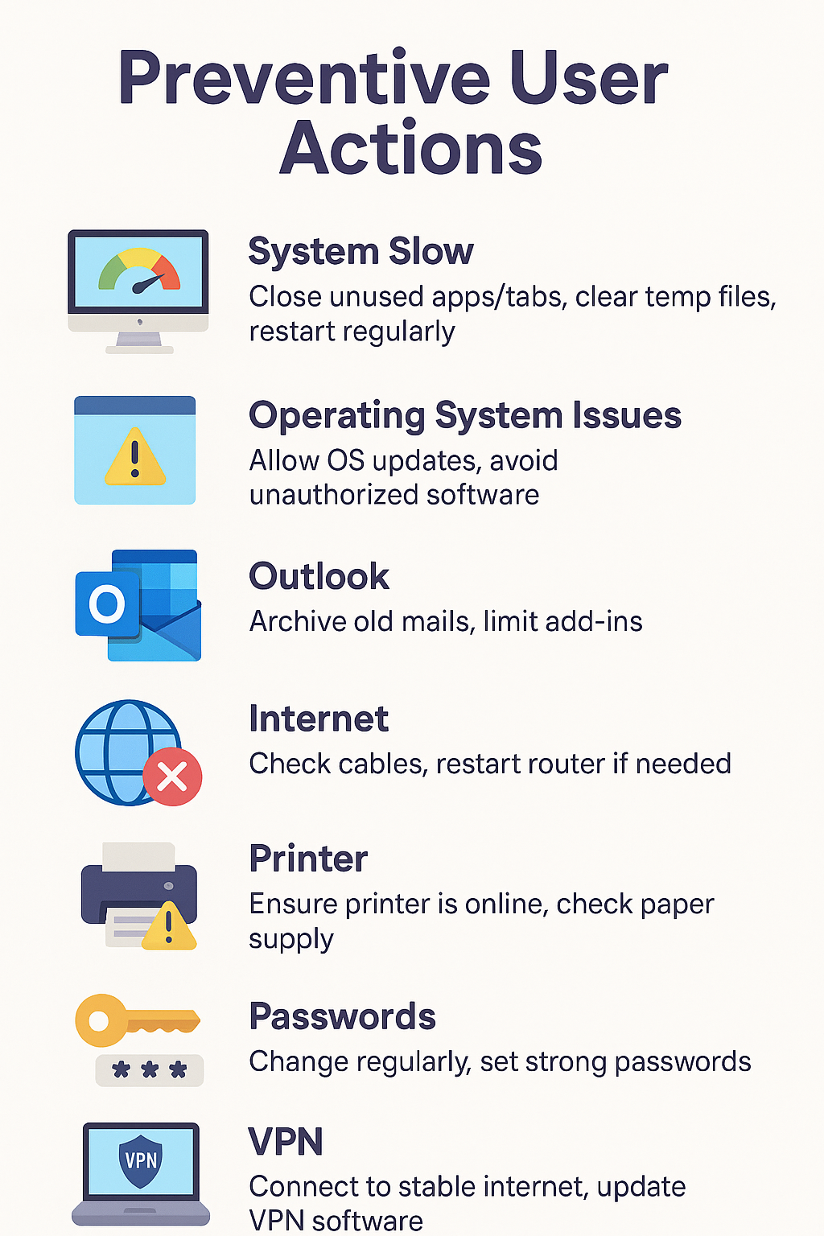

IMPACT OF PREVENTIVE USER ACTIONS
(After Following Suggested Precautionary Steps)
To address repeated IT tickets and enhance user experience, a set of preventive actions was recommended for users. Once these actions were adopted, the following tangible and strategic impacts were observed:

🔄 1. REDUCTION IN REPEATED IT TICKETS
- Significant drop in frequently raised issues such as password resets, printer errors, Outlook problems, and system slowness.
- Helpdesk ticket volume decreased by approximately 20–30% in categories where user actions were involved.
- Improved efficiency in IT support team operations due to fewer repetitive tasks.

⚙️ 2. IMPROVED SYSTEM PERFORMANCE AND OS STABILITY
- Users experienced smoother, faster systems.
- Fewer complaints about system freezes, crashes, or lag.
- Reduced need for IT escalation or OS reinstallation.

📧 3. BETTER OUTLOOK AND EMAIL MANAGEMENT
- Faster email sync and fewer issues with slow or unresponsive Outlook.
- Regular archiving and mailbox maintenance helped avoid data corruption or storage overload.

🌐 4. STABLE INTERNET AND VPN CONNECTIVITY
- Fewer disruptions during remote work or video calls.
- Less reliance on IT for home or office network issues.
- Improved VPN login success and continuity.

🖨️ 5. STREAMLINED PRINTER USAGE
- Common problems like "printer offline" or "queue stuck" were resolved at user-level before escalating.
- Reduced printing delays and fewer support tickets raised for minor printer issues.

🔐 6. INCREASED PASSWORD & ACCOUNT SECURITY
- Reduced lockout incidents due to expired or mistyped passwords.
- Higher awareness about strong password practices and password reset timelines.
- Lower risk of security breaches or unauthorized access.

📈 7. OVERALL ORGANIZATIONAL BENEFITS
- IT team can focus on strategic issues rather than firefighting repeated user mistakes.
- Users became more self-reliant and IT-aware, leading to a culture of responsible technology usage.
- Cost savings due to lower support demand and downtime.
- Increased user satisfaction and productivity.

This result demonstrates that end-user training and preventive awareness can be a powerful, low-cost strategy to reduce repeated IT tickets, optimize support efforts, and enhance business continuity.

Chapter 6: Conclusion

This study demonstrates that a significant proportion of IT support tickets—particularly related to Outlook, Internet, Laptop performance, and Printer configuration—are repetitive and preventable. Over 55–60% of the analysed 922 tickets were found to be user-resolvable through basic awareness and training. The findings affirm that user training is not just an operational necessity but a strategic lever for improving IT efficiency and user satisfaction.

BUSINESS RECOMMENDATIONS
- Implement Structured User Training Programs:
  - Develop interactive and gamified training modules on common IT issues.
  - Include basic troubleshooting in on boarding for all new employees.
- Promote Self-Service Channels:
  - Launch a knowledge base, FAQs, and Chabot for first-level resolutions.
  - Automate recurring tasks such as password resets and software installs.
- Regional and Departmental Focus:
  - Prioritize the West region, which generated over 80% of the tickets.
  - Tailor training based on department-specific recurring issues.
- Continuous Monitoring & Feedback:
  - Set up dashboards to track ticket trends and training effectiveness.
  - Gather user feedback post-training to refine content.
- Engineer Performance Optimization:
  - Recognize top-performing support staff.
  - Balance workloads and promote peer learning among engineers.

STRATEGIES FOR IMPROVEMENT
- Preventive User Education: Conduct quarterly refresher sessions with real-time examples from ticket history.
- Infrastructure Optimization: Improve Wi-Fi coverage, standardize printer hardware, and schedule laptop health checks.
- Ticket Categorization Clean-Up: Correct misclassifications (e.g., duplicate "Desktop" entries) to improve analysis accuracy.
- Behavioural Targeting: Identify and coach repeat users (like James, Brian, and Robert) for faster behavioural change.

LIMITATIONS OF THE STUDY
- Scope Constraint: The study is limited to end-user desktop support tickets and does not cover backend/server-related IT issues.
- Regional Bias: Majority of data came from the West region, which may not reflect the complete organizational scenario.
- Limited Survey Sample: Only 50 users were surveyed; a broader sample could yield more generalized results.

FUTURE AREAS OF STUDY

- Longitudinal Analysis: Track ticket trends for a year post-training to measure sustained impact.
- AI and Automation Integration: Study the effect of chatbots, virtual agents, and predictive analytics in reducing first-level tickets.
- Cross-Industry Benchmarking: Compare repeated ticket trends across similar organizations to identify best practices.
- Behavioural Impact: Investigate how user attitudes, digital literacy, and learning retention influence ticket volumes over time.

Bibliography (Books, Journals, Research work)

BOOKS & FRAMEWORKS:
- Axelos. ITIL Foundation: ITIL 4 Edition. TSO (The Stationery Office), 2019.
- Laudon, Kenneth C., and Jane P. Laudon. Management Information Systems: Managing the Digital Firm. Pearson Education, 2020.
- Turban, Efraim, and Linda Volonino. Information Technology for Management: Advancing Sustainable, Profitable Business Growth. Wiley, 2018.
- Sharma, R., & Gupta, P. Essentials of IT Service Management. McGraw Hill Education, 2021.

ACADEMIC JOURNALS:
- Sharma, A., et al. “Impact of User Training on IT Helpdesk Ticket Reduction.” International Journal of ITSM, vol. 9, no. 2, 2020, pp. 45–52.
- Bhardwaj, R., & Verma, A. “Digital Literacy and Its Impact on IT Support Efficiency in Corporates.” Journal of Enterprise Information Management, vol. 32, no. 4, 2019.
- Kapoor, S. “Gamification in IT Training: Enhancing User Engagement.” Indian Journal of Management Studies, vol. 14, no. 1, 2021.

RESEARCH & INDUSTRY REPORTS:
- Gartner. “IT Service Desk Automation Report.” Gartner Research, 2021. www.gartner.com
- Forrester. “Self-Service IT Support Improves Help Desk Efficiency.” Forrester Insights, 2022. www.forrester.com
- Deloitte. “Digital Workplace Trends and Employee Readiness.” Deloitte Insights, 2021. www2.deloitte.com
- Capgemini. “Digital Learning and Gamified Training Report.” Capgemini Research Institute, 2020. www.capgemini.com

IT SERVICE & SUPPORT PORTALS:
- HDI. “Support Centre Practices & Metrics.” HDI Reports, 2022. www.thinkhdi.com
- Service Now. “The Rise of Self-Service Portals in ITSM.” Service Now Blog. www.servicenow.com/blogs.html
- Microsoft Docs. “Optimize Outlook Performance.” Microsoft TechNet, 2023. https://learn.microsoft.com

Reference (Website)

Capgemini. (2020). Digital Learning and Gamified Training Report. Retrieved from https://www.capgemini.com
- Deloitte. (2021). Digital Workplace Trends and Employee Readiness. Retrieved from https://www2.deloitte.com
- Forrester Research. (2022). Self-Service IT Support Improves Help Desk Efficiency. Retrieved from https://www.forrester.com
- Gartner. (2021). IT Service Desk Automation Report. Retrieved from https://www.gartner.com
- HDI. (2022). Support Centre Practices & Metrics. Retrieved from https://www.thinkhdi.com
- Microsoft. (2023). Optimize Outlook Performance. Retrieved from https://learn.microsoft.com
- Service Now. (2023). The Rise of Self-Service Portals in ITSM. Retrieved from https://www.servicenow.com/blogs.html
- Axelos. (2019). ITIL v4: Best Practice Framework for IT Service Management. Retrieved from https://www.axelos.com

